January 17, 2024

**WEEKLY ACOMPLISHMENT REPORT DCS 1A**

**Project Title: WEB APPLICATION FOR BARANGAY INFORMATION SYSTEM (BIS)**

***BARANGAY DACASA UNO***

**Group PAYB**

Team Members:

Lord Jeremy Madrona, Jalandoon

Pauline May Laluna,Larquesa

Glairisha Caragay, Isidro

Ramuel Tanega,De Luna

Eduardo Battung,Santos

**Task/Objective:**

Develop an interactive and responsive web application to facilitate efficient and transparent communication within our target Barangay citizens.

**Report in Web Developing**

The Barangay System Information web application aims to streamline communication and information dissemination within a barangay community. The development process involves various stages, and this report will delve into the specifics of designing and implementing the navbar and footer components.

Navbar Design and Implementation:

The navbar serves as the primary navigation tool for users, enabling them to navigate through different sections of the web application efficiently. The design process involves considering user experience (UX), visual aesthetics, and responsiveness across various devices. It is designed to prioritize essential features, providing users with quick access to critical sections such as announcements, resident information, and community events.

Footer Design and Implementation:

The footer is a critical component that often contains important information, links, and contact details. It contributes to the overall website usability and complements the navbar in providing a comprehensive user interface.

Future development efforts will focus on continuous improvement based on integration of additional features, and enhancements to ensure the scalability and sustainability of the web application.

**STATUS OF CODE AND OUTPUT**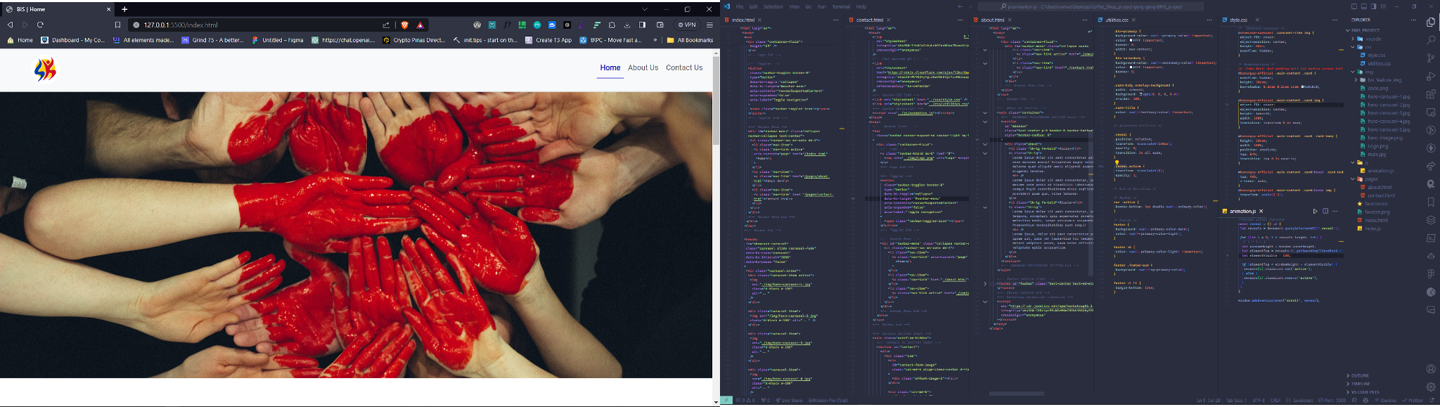



# Hero section

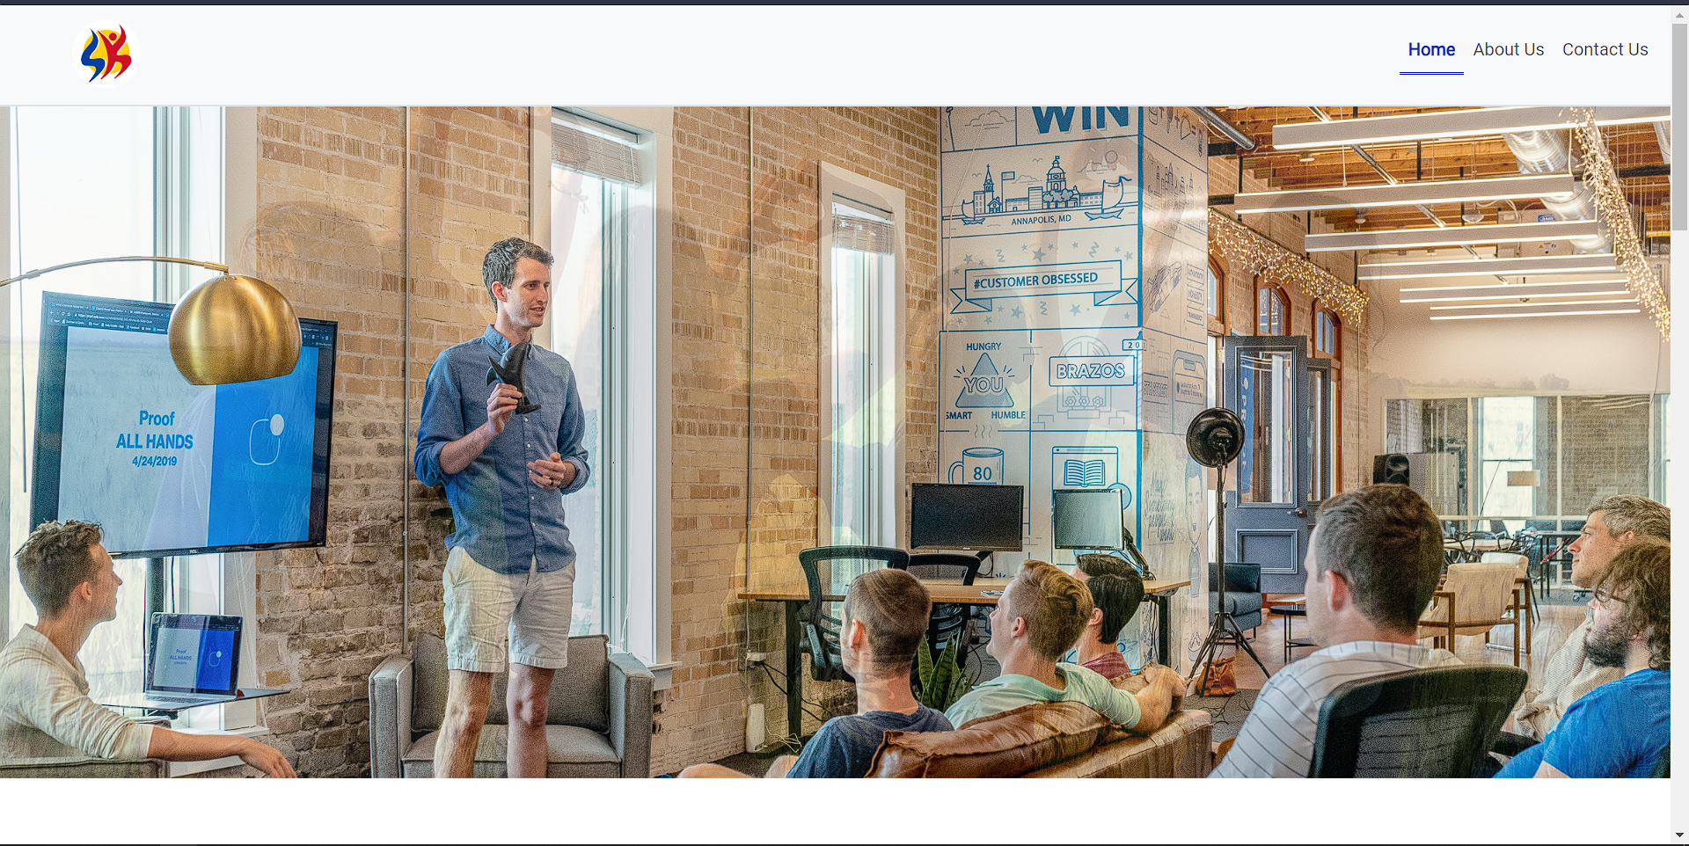

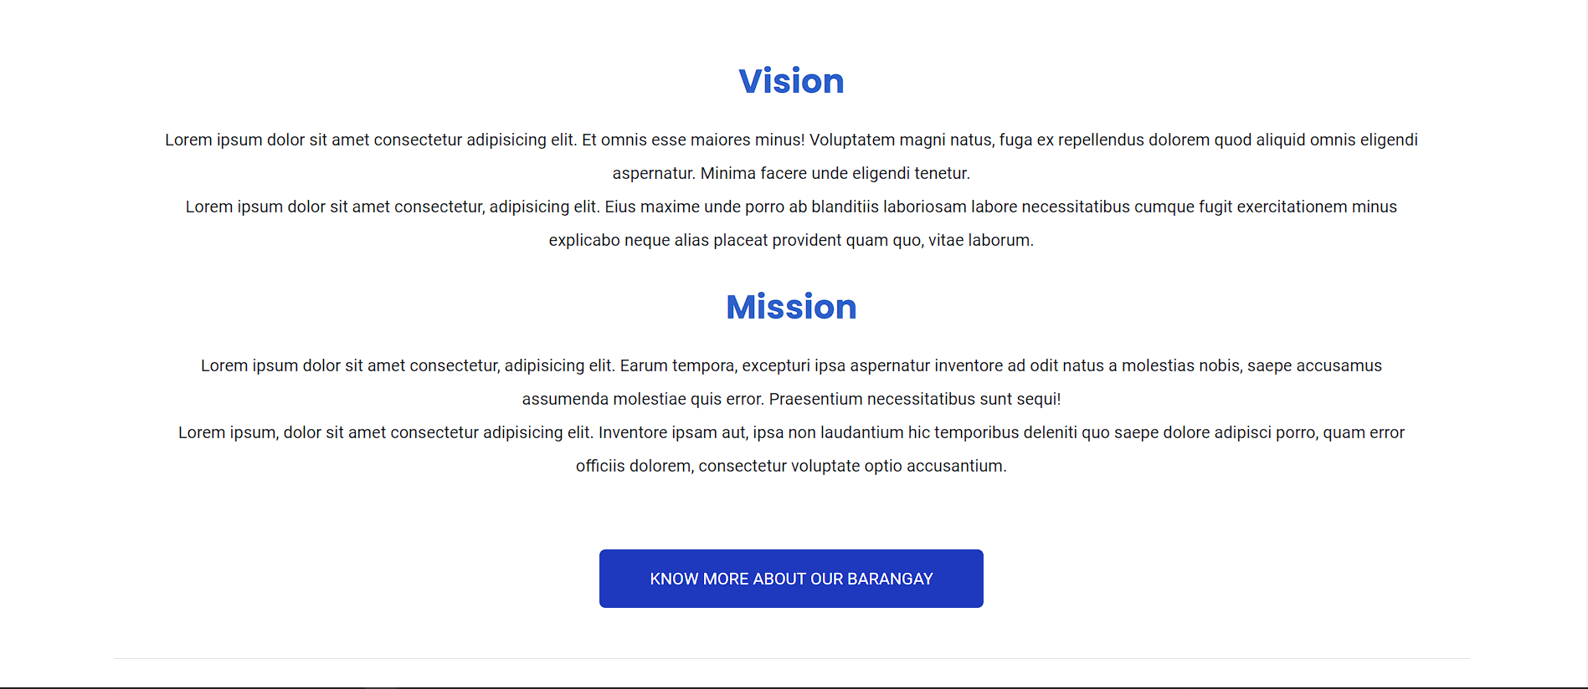

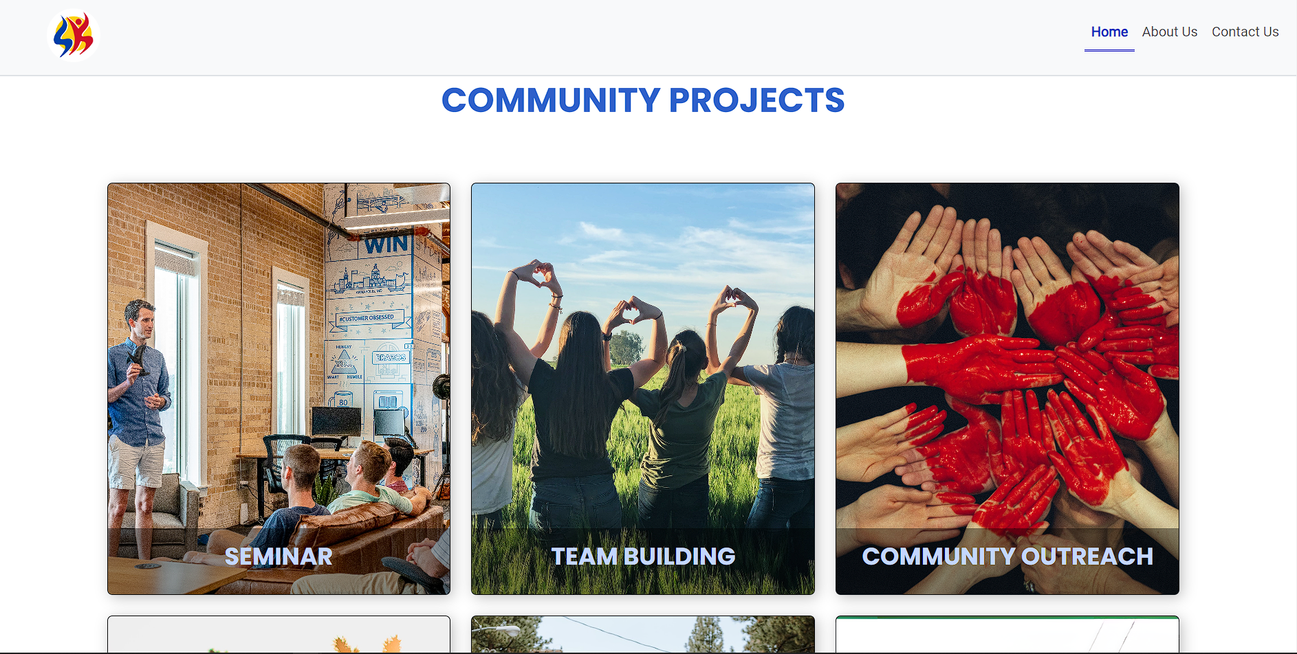

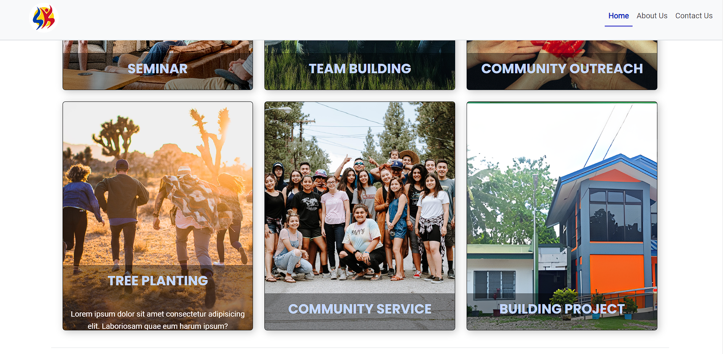

# Footer

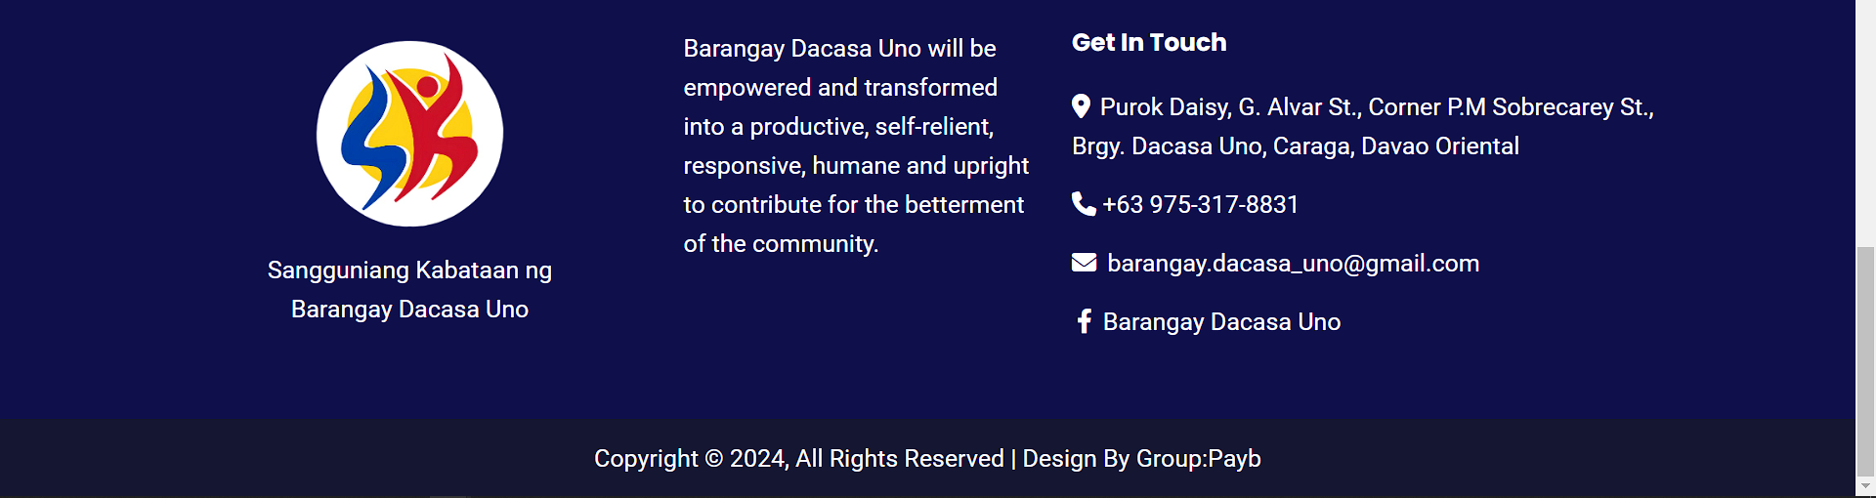

# About page

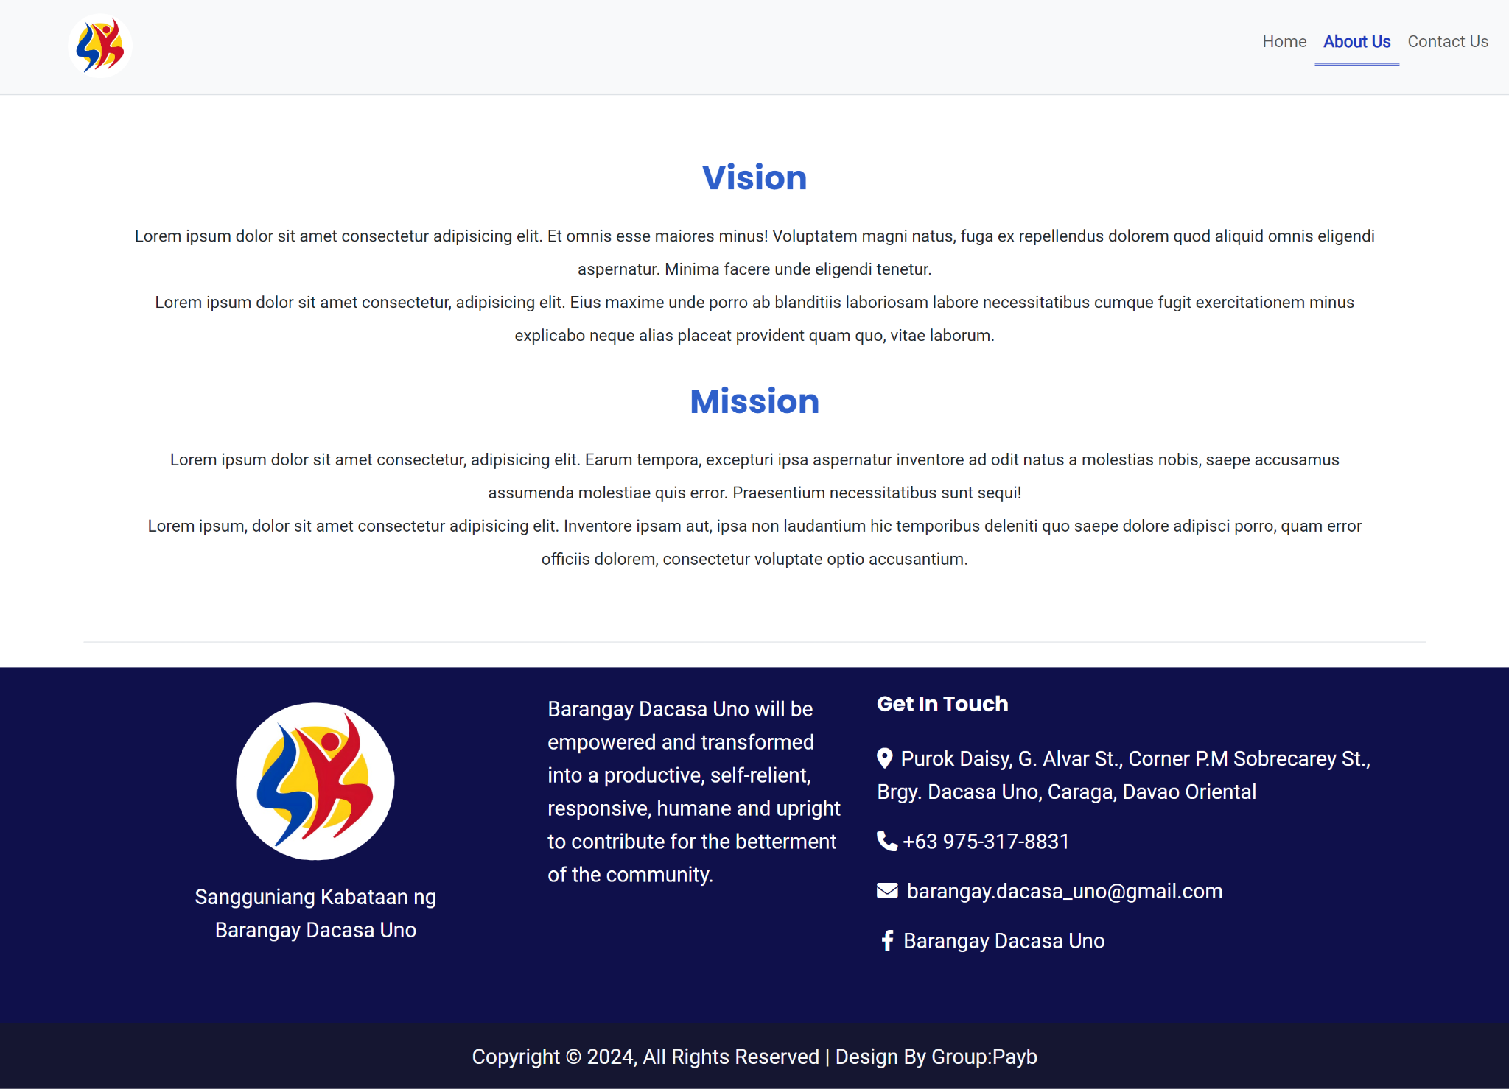

# Contact Page

